*Start a new Python project folder … do not reuse the previous workspace … As with any keyboard-driven console-like environment, developing muscle -memory for the common commands is also part of the learning curve.*

* Natural Language Processor (NLP) - Is a field in computing concerned with the ability of a computer to understand, analyze, manipulate, and potentially generate human language. A language that could be used for everyday communication. Just like Machine Learning (ML) and Artificial Neural Network (ANN), NLP is a branch of artificial intelligence.
* Some examples of the usage of NLP:
* **Spam Filter**: 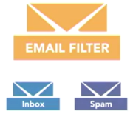to determine whether an incoming email is spam or not by scanning the content body, subject, and domain.
* **Auto-Complete**: 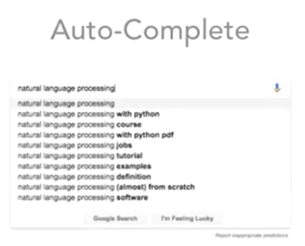 to predict what users are interested in searching based on what you already entered and what others commonly searched for based on those same entries.
* **Auto-Correct**: 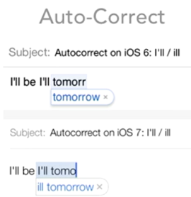to help user correct misspellings where it evolves over time to learn.
* **Chatbots**: to help customer service, or help diagnose customers’ problems or illness.
* NLP encompasses many other topics including sentiment analysis, topic modeling, text classification, sentence segmentation or part-of-speech tagging.
* The tools we need is Natural Language Toolkit (NLTK for short). It is the most popular used toolkit to handle NLP processes in Python. Suite of open-source tools created to make NLP processes in Python easier to build.
* Downloading and setting up NLTK.
* Visit this link, download, and install: <https://pypi.org/project/nltk/>
* If you are also running jupyter notebook, make sure that you find at the back of jupyter window, the running NLTK installer program, select all packages, wait for about 4 minutes to install all . . .

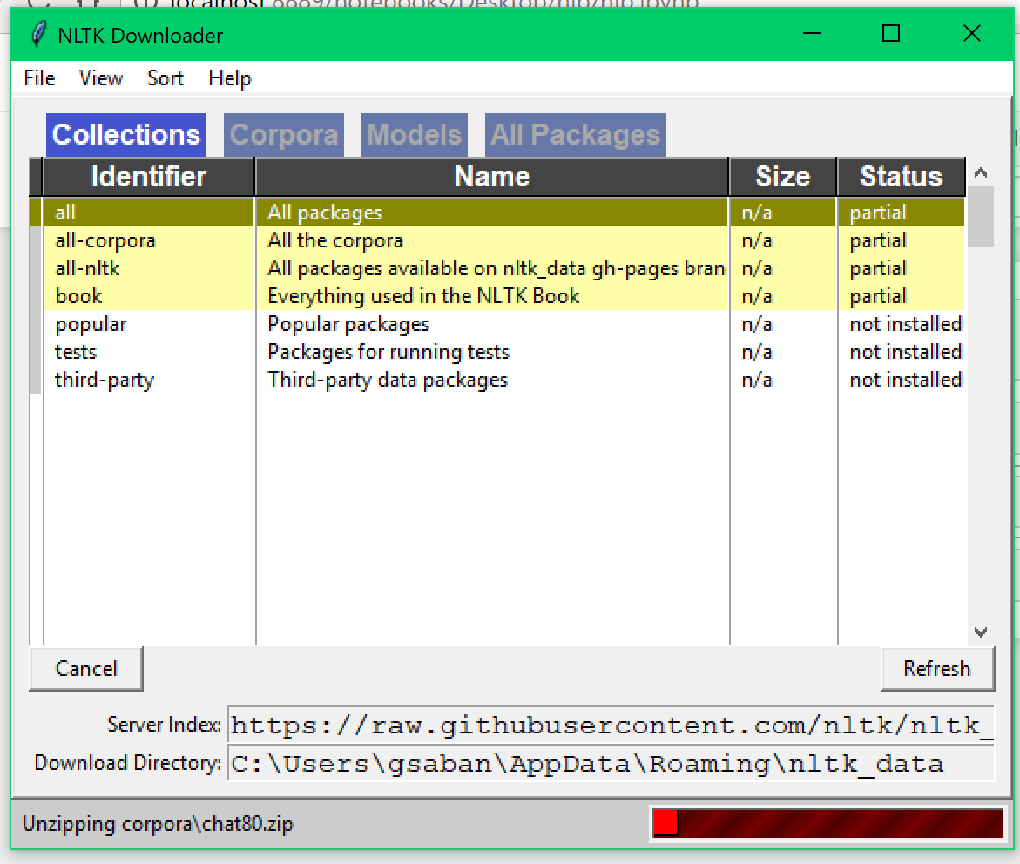

* When your jupyter notebook folder tab icon is like below, that means it is not done yet.

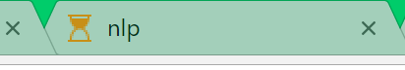

* When done installing, close the NLTK Installer window.
* 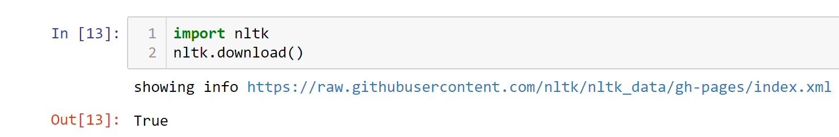
* If the NLTK Installer window appears again, close it and you will see the output displays True
* 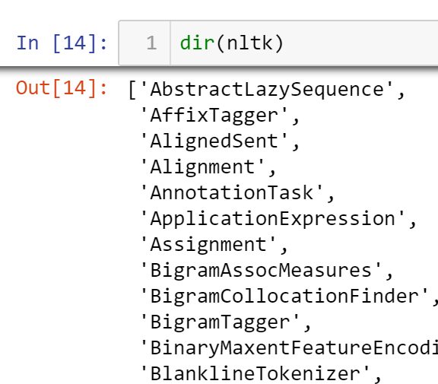
* Directory displays all the functions and attributes on this package.
* Scroll down the directory list and find *pos_tag* and *tokenize* functions of NLP; you get to use that soon.
* Importing stopwords, and displaying the first ten words
* 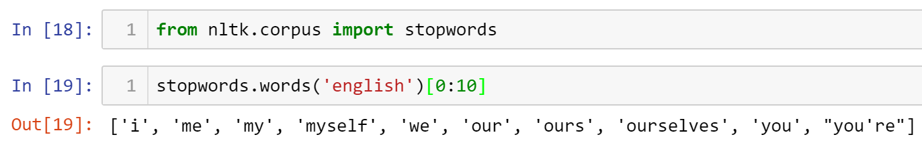
* Displaying the stopwords from 0 to 500 and only showing increments of 25.
* 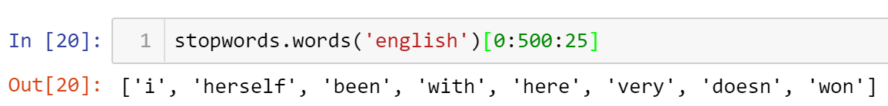
* Stopwords are words that are used very frequently, but don’t really contribute much to the meaning of the sentence. They are sentiment neutral, and there are no strong meaning associated with them. So these are words that you can drop.
* All submissions should be separate from other exercises and quests. Please do not lump all your answers into one document and re-using that same workspace to gain multiple points. Thanks.
* Place your name at the bottom of your code, download your Python program in html format, and submit your work in Canvas.